Effects of N-enriched Leaf Litter and Decreased Temperatures on *Aedes aegypti* Mosquito Larvae Development Time and Biomass

**BIO 150: Climate Chang**e

The third section of BIO 150 focuses on the effect climate change has on biological interactions. We covered biological concepts such as nutrient regulation and cycling, homeostasis, population balance, weather, and complex interactions between members of an ecosystem. For the first two experiments, we examined the response of developing *Brassica rapa* (turnip seed) to determine the responses of crop plants to temperature, and then elevated CO2 levels. In particular, we focused on environmental change in the context of anthropogenic climate change as a result of the addition of greenhouse gasses, with growth-chamber experiments in which CO2 concentrations and temperatures are modified being our most utilized experimental format.

**Introduction**

With the current trends of anthropogenic climate change indicating severe changes to the global ecosystem within the next century, it will undoubtedly have an effect on mosquitoes. Mosquitos are of interest because they are a cosmopolitan species of disease vectors and infect and kill millions annually[1]. Mosquito eggs are usually laid in still freshwater closer to the shore where bacteria, algae, and microorganisms all decompose organic matter. Mosquito larvae eat these critters, while they in turn are dependent on one another for nutrient cycling from the organic matter. Commonly it is senesced plant material like leaf litter. From what we know about photosynthetic carbon fixation (growth), higher CO2 levels mean more carbon fixation which increases nitrogen consumption. Nitrogen is often a limited resource, so increase in CO2 would increase the carbon to nitrogen (C:N) ratio. Previous studies have shown that a higher C:N ratio decreases decomposition rates of organic matter, as well as that increased C:N ratios negatively affect mosquito larval development times. For aquatic detritivores biomass decreases when developing in higher tolerable temperatures. Due to time restraints, we were unable to acquire leaf litter grown in CO2 enriched environments, so to simulate the inverse opposite effect, we instead enriched ash leaf litter with nitrogen in order to achieve a similar C:N ratio that would be found within leaf litter grown in CO2 reduced environments, and using and ambient C:N as a control. This means that we will have to decrease temperatures for a decreased C:N ratio to keep the variables in proper relation to each other. The reasoning behind this is that by determining the response of mosquitoes to past environmental conditions we can predict the response of mosquitoes to future environmental conditions of increased CO2 and increased temperature, assuming that the curve of [CO2] and temperature are calculable functions.

Experimental Design: 80 larvae, 20 replicates, four groups with a factorial ANOVA to compare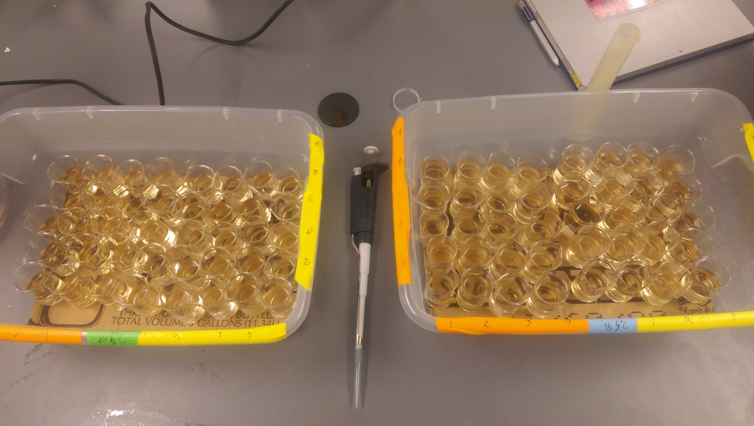 effects of variables.

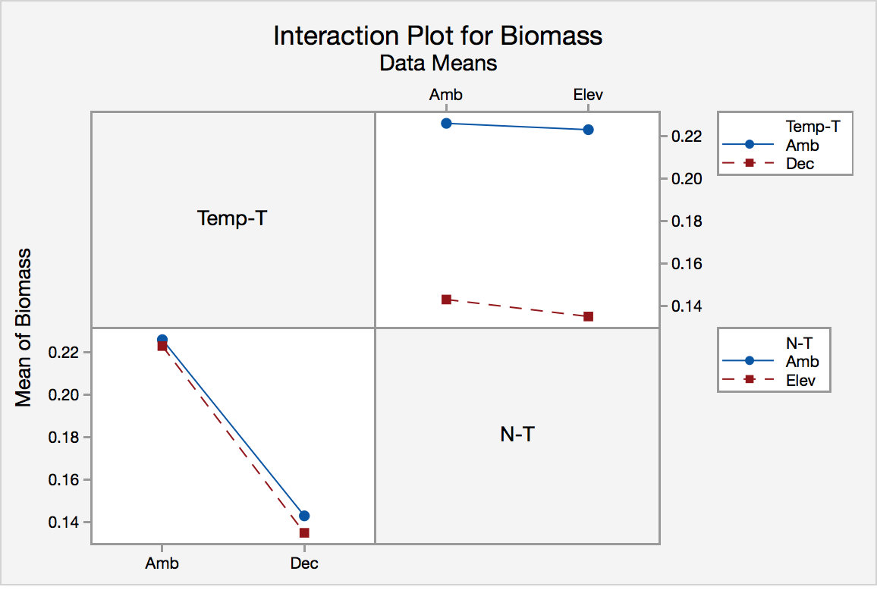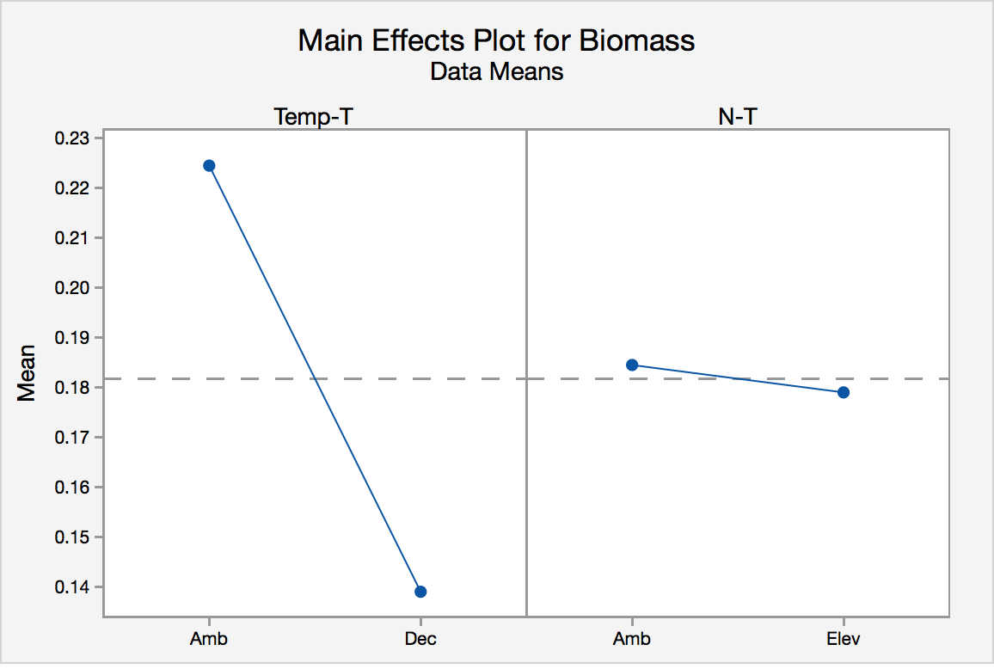

1). Are our methodology and experimental designs sound?

2). What are your suggestions regarding how this experiment could be improved if it were to be run again?

1. Caraballo, Hector (May 2014). ["Emergency Department Management Of](http://www.ebmedicine.net/topics.php?paction=showTopic&topic_id=405)

   [Mosquito-Borne Illness: Malaria, Dengue, And West Nile Virus"](http://www.ebmedicine.net/topics.php?paction=showTopic&topic_id=405). *Emergency Medicine*

   *Practice*. 16 (5).